Chapter 19, Problem 93.

Calculate A_{v}, A_{i}, Z_{in}, and Z_{out} for the transistor network in Fig.19.132. Assume that

h_{ie} = 2 kΩ, h_{re} = 2.5 × 10⁻⁴

h_{fe} = 150, h_{oe} = 10 μ S

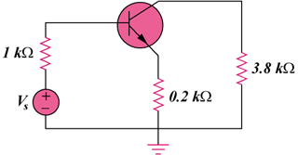
Figure 19.132
For Prob. 19.93.

